National Coral Reef Monitoring Program

Climate Monitoring Brief: St. Croix, USVI

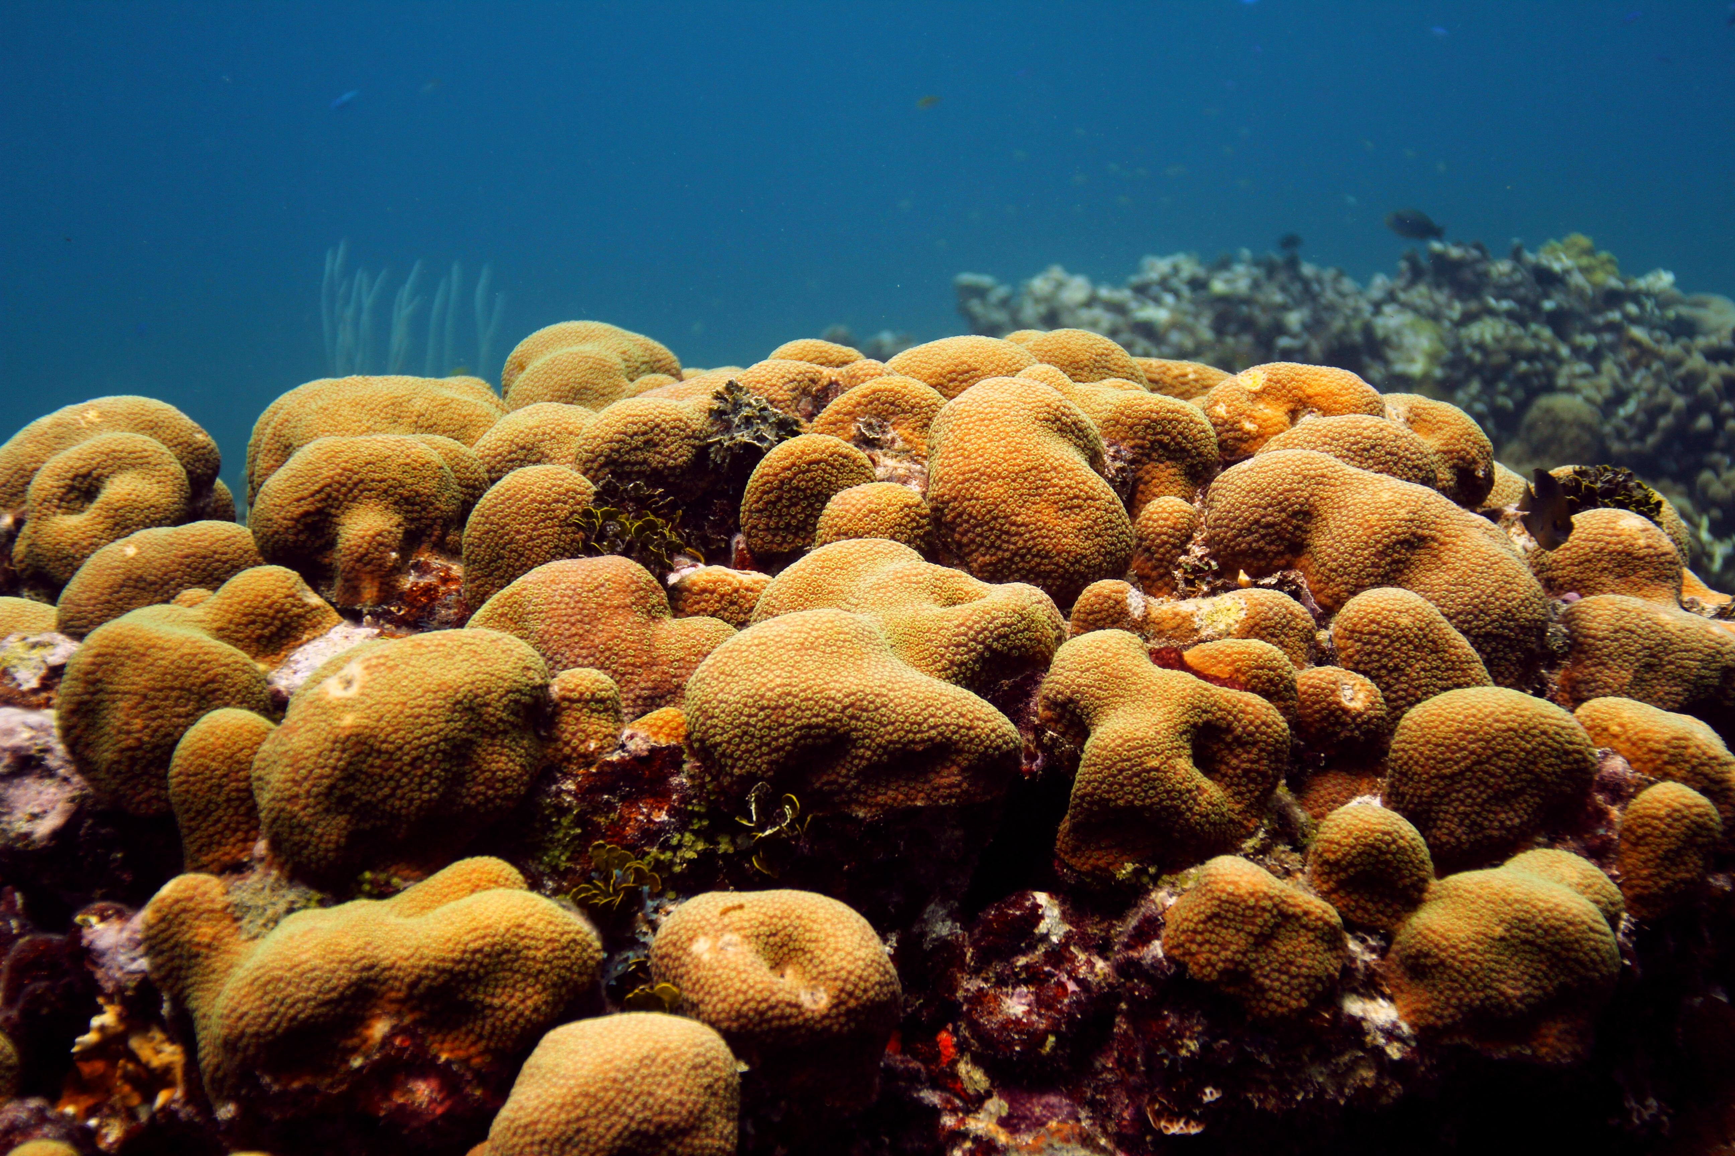

Orbicella faveolata in St. Croix, USVI

Atlantic Oceanographic & Meteorological Laboratory Coral Program University of Miami Cooperative Institute of Marine and Atmospheric Science National Oceanic Atmospheric Administration

N. Besemer, A. Palacio, A. Webb, G. Kolodziej, M. Chakraborty, I. Enochs - October 2022

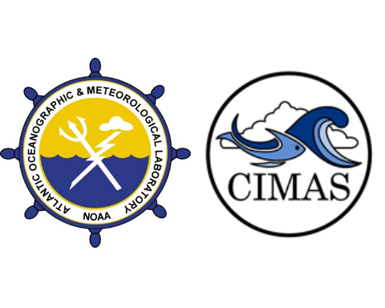

### About this summary brief

The NOAA Atlantic Oceanographic and Meteorological Laboratory (AOML) conducts the long-term National Coral Reef Monitoring Program (NCRMP) to track the status and trends of coral reef ecosystems of the U.S. Atlantic and Caribbean coral reef jurisdictions. This summary brief provides an overview of the most recent survey efforts to St. Croix USVI.

### Expedition summary

* The NCRMP Atlantic climate monitoring team recently traveled to St. Croix in the US Virgin islands from September 4th to September 9th, 2022
* 16 different sites were visited by four team members and collaborators completing a total of 45 dives.
* These sites represent temporal‐resolution monitoring with moored instruments at fixed time‐series which are placed on depth gradient to assess how vertical structure affects reef status and trends.

### Data collection

* Subsurface **temperature** recorders (STRs) were recovered and redeployed at all 4 transects, each one composed by 3-4 depths (Fig. 1). Overall, more than 4 million temperature observations were collected:

Table 1: Number of temperature observations collected by transect and depth

| Transect | 21m | 25m | 30m | 35m | Total |
| --- | --- | --- | --- | --- | --- |
| East | 351,055 | 334,670 | 334,675 | 334,873 | 1,355,273 |
| West | NA | 399,148 | 446,378 | 529,033 | 1,374,559 |

* At Salt River, the north side of St. Croix, short term instruments (72h) were deployed to monitor daily fluctuations in:
  + **Current**: 286 observations
  + **pH**: 285 observations
  + **Light**: 288 observations
  + **Carbonate Chemistry**: XX samples collected
  + **Benthic cover**: XX landscape mosaics
  + **Carbonate budget surveys**: Benthic cover, sponge, urchin and parrotfish surveys completed at XX transects
* Additionally, changes in bioerosion and accretion were monitored at all 15m sites by recording:
  + **Bioerosion**: 39 Bioerosion Monitoring Units (BMUs) collected, 40 redeployed
  + **Calcification**: 18 Calcification Accretions Units (CAUs) collected, 20 redeployed

**Figure 1:** Study sites and depths in St. Croix, USVI

#### Temperature

Three years of temperature measurements were retrieved and processed from 14 sites (depths). Temperature was measured using SeaBird Electronics Subsurface Temperature Recorders (STR)s that collected data at 5-minute intervals.

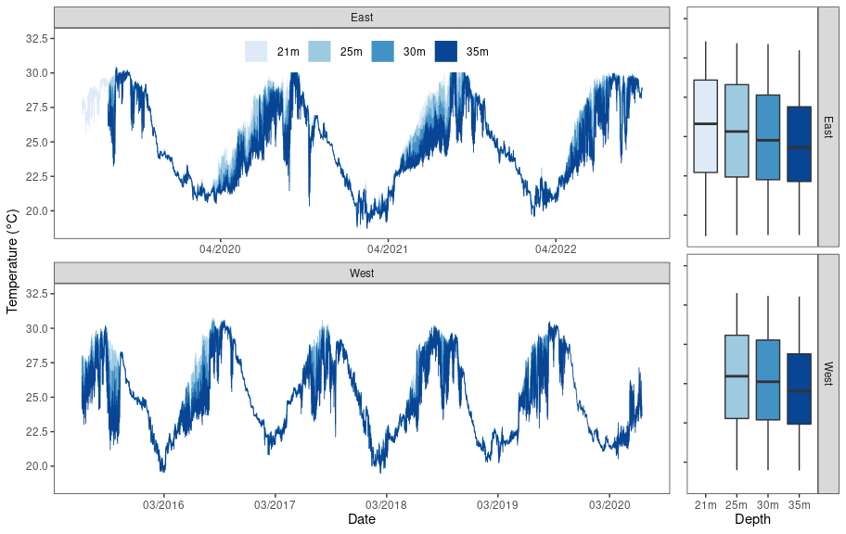

**Figure 2:** Temperature conditions at four transects in St. Croix (east, west, north and south) representing a depth gradient (1m, 5m, 15m and 25m). Data were collected from September 2019 to September 2022. However, STR from north station - 25m stopped recording earlier on February 2022 and STRs from south station - 1m on November 2011.

Temperature values were similar among the transects and depths depths with the lowest temperatures generally occurring in March (mean: 26.56 $​^{∘}$ C, min: 25.64 $​^{∘}$ C, max: 28.27 $​^{∘}$ C) and the the highest temperatures in September (mean: 29.68 $​^{∘}$ C, min: 27.22 $​^{∘}$ C, max: 32.11 $​^{∘}$ C). The south 1m station presented the highest temperature variability and the maximum temperature values recorded in October 2021 (32.16 $​^{∘}$ C) and September 2020 (32.11 $​^{∘}$ C) (Fig. 2).

#### Diurnal Suite Deployment

At the North 15m site, Salt River Bay, additional instruments were deployed for a 72-hour diurnal suite that monitored pH, temperature, light and current speed (Fig. 3). The SeaFET pH logger, EcoPAR and Tiltmeter collected measurements at 15-minute intervals.

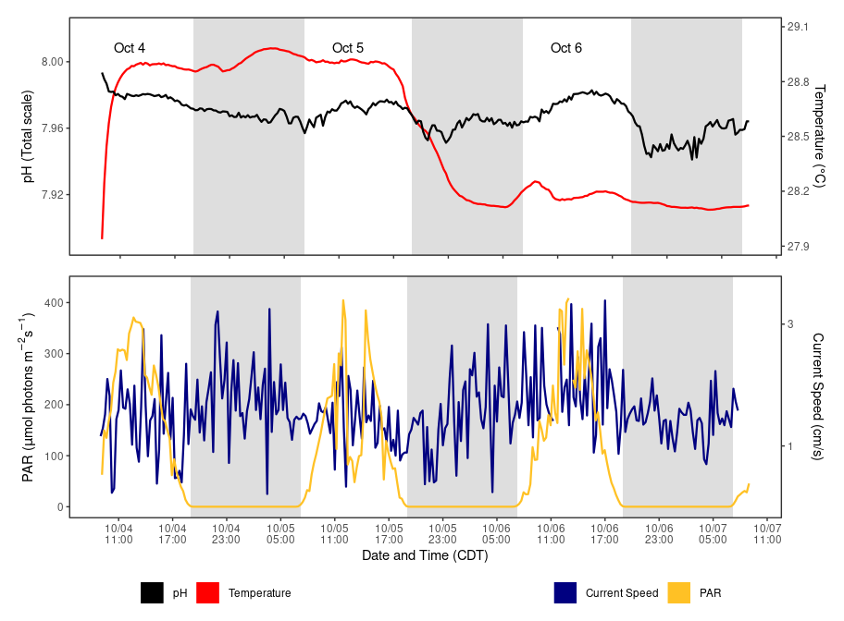

**Figure 3:** Salt River Bay (N 15m) diurnal suite monitoring from September 5th to 8th. Top panel: pH and temperature from SeaFET. Bottom panel: Photosynthetically Available Radiation (PAR) and current speed from EcoPAR and Tiltmeter. Grey blocks denote night time throughout sequence of the plot. Instruments measured parameters every 15 minutes.

As part of the diurnal suite, discrete water samples were collected at three-hour intervals (n=15) using Subsurface Automatic Samplers (SAS). These samples will be analyzed for Total Alkalinity (TA), Dissolved Inorganic Carbon (DIC), and Spectrophotometric pH (SpecpH). Using these metrics we can get the calculated values for pCO2 and aragonite saturation state. For more information on SAS vist <https://www.coral.noaa.gov/accrete/sas/>

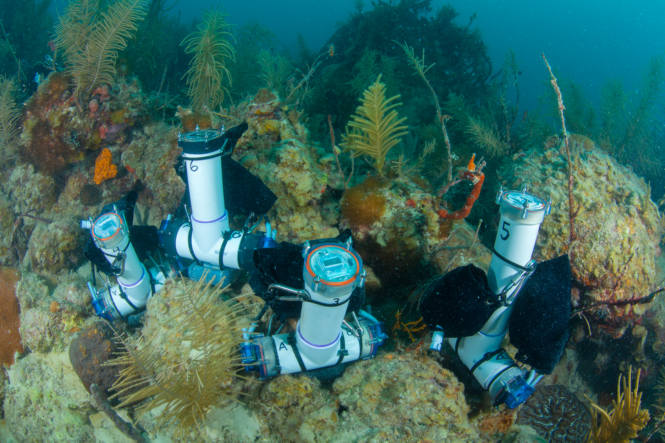

Submered Automated Samplers (SAS) deployed to collect water samples every 3 hours

#### Carbonate budgets

At Salt River Bay, six transects were established and surveyed in 2019 to obtain carbonate budgets which describe the summation of all processes contributing to calcification and bioerosion on a reef. This metric is used to determine if a reef is in a state of net accretion; growing or net loss; flattening. We revisited this site and recorded the abundance and cover of all major carbonate producing (coral and CCA) and eroding taxa (urchin, bioeroding sponges and parrotfish) to find out the new carbonate budget status after 3 years.

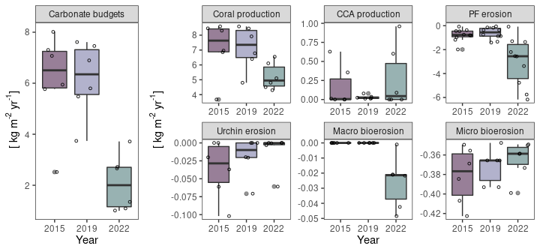

**Figure 4:** Carbonate budgets Salt River Bay in 2019 and 2022 and the processes contributing to calcification and bioerosion. Carbonate budgets declined in 2022 compared to 2019, mainly due to the reduction in coral production and the increase in urchin erosion.

The transect results showed that carbonate budgets have become negative in 2022, which implies that this site has shifted to being net erosional over the past 3 years.

#### Other Deliverables

* **Calcification Accretion Units (CAUs)** and **Bioerosion Monitoring Units (BMUs)** were collected and redeployed for the next sampling cycle. CAUs are processed by the Pacific Climate group and the data will be available within a year. BMUs will be dried and cleaned using a hydrogen peroxide solution. These samples will be weighed and scanned using a Macro CT scanner and then compared to their pre-scans to quantify bioerosion. Data will be available in a year. Please reference previous datasets for more information.

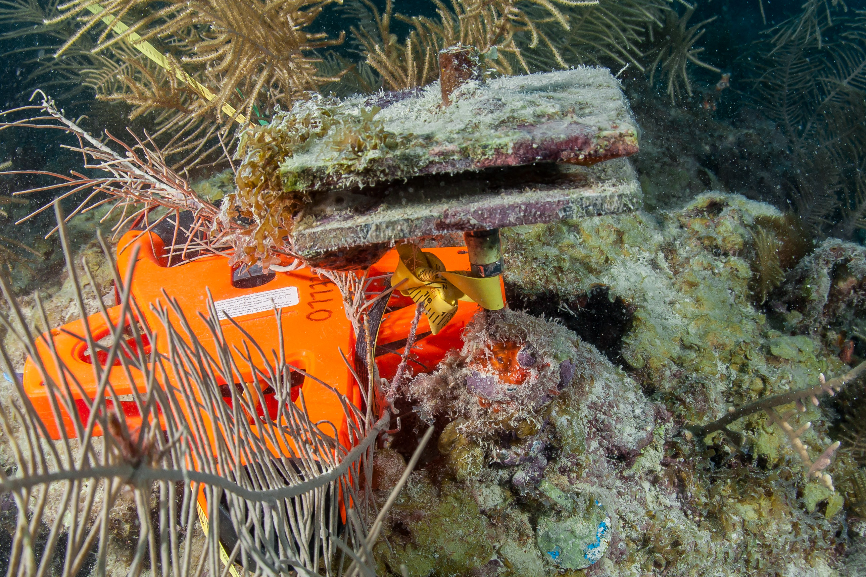

CAU and BMU pair before retreval after being deployed for 3 years. CAUs are 2 parallel PVC plates to quantify settled accretors. BMU is mounted coral skeleton installed at the base of the metal stake and has been encrusted.

* **Landscape mosaics** (n=6) were completed to monitor changes in benthic cover.

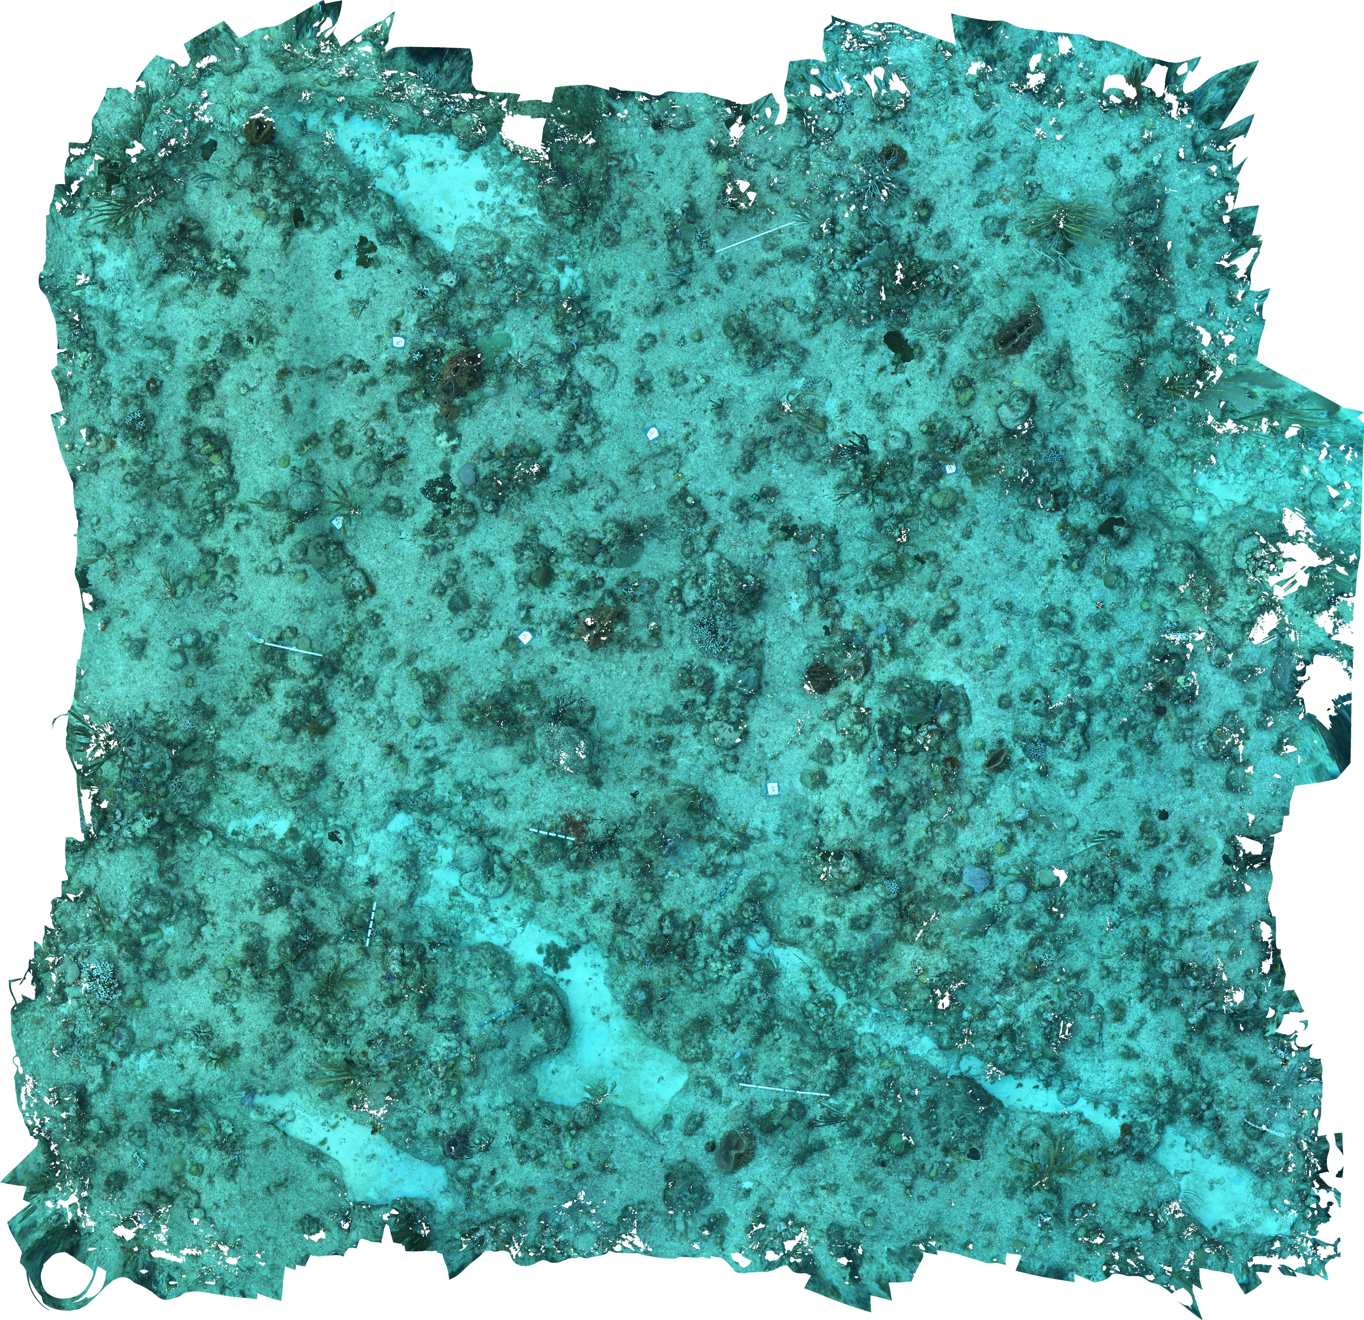

Landscape Mosaic collected from transect 6

### About the monitoring program

AOML’s climate monitoring is a key part of the National Coral Reef Monitoring Program of NOAA’s Coral Reef Conservation Program (CRCP), providing integrated, consistent, and comparable data across U.S. Managed coral reef ecosystems. CRCP monitoring efforts aim to:

* Document the status of reef species of ecological and economic importance.
* Track and assess changes in reef communities in response to environmental stressors or human activities.
* Evaluate the effectiveness of specific management strategies and identify actions for future and adaptive responses.

### Point of Contact

Atlantic Climate team lead: [nicole.besemer@noaa.gov](mailto:nicole.besemer@noaa.gov)

Principal Investigator: [ian.enochs@noaa.gov](mailto:ian.enochs@noaa.gov)

NCRMP Coordinator: [erica.towle@noaa.gov](mailto:erica.towle@noaa.gov)

### For more information

Coral Reef Conservation Program: <http://coralreef.noaa.gov>

NCRMP climate monitoring: <https://www.coris.noaa.gov/monitoring/climate.html>

NOAA Atlantic Oceanographic and Meteorological Laboratory: <http://www.aoml.noaa.gov/>

[USVI Reef Status Report 2020](https://www.coris.noaa.gov/monitoring/status_report/docs/USVI_508_compliant.pdf)

[National Coral Reef Status Report 2020](https://repository.library.noaa.gov/view/noaa/27295)

### Acknowledgements

These efforts were jointly funded by NOAA’s CRCP and OAP. We would like to sincerely thank the National Park Service as well as Caribbean Sea Adventures for supporting our field efforts and assisting monitoring surveys

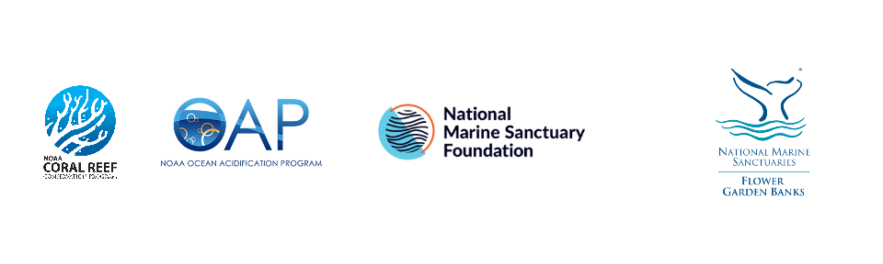

### Our Team

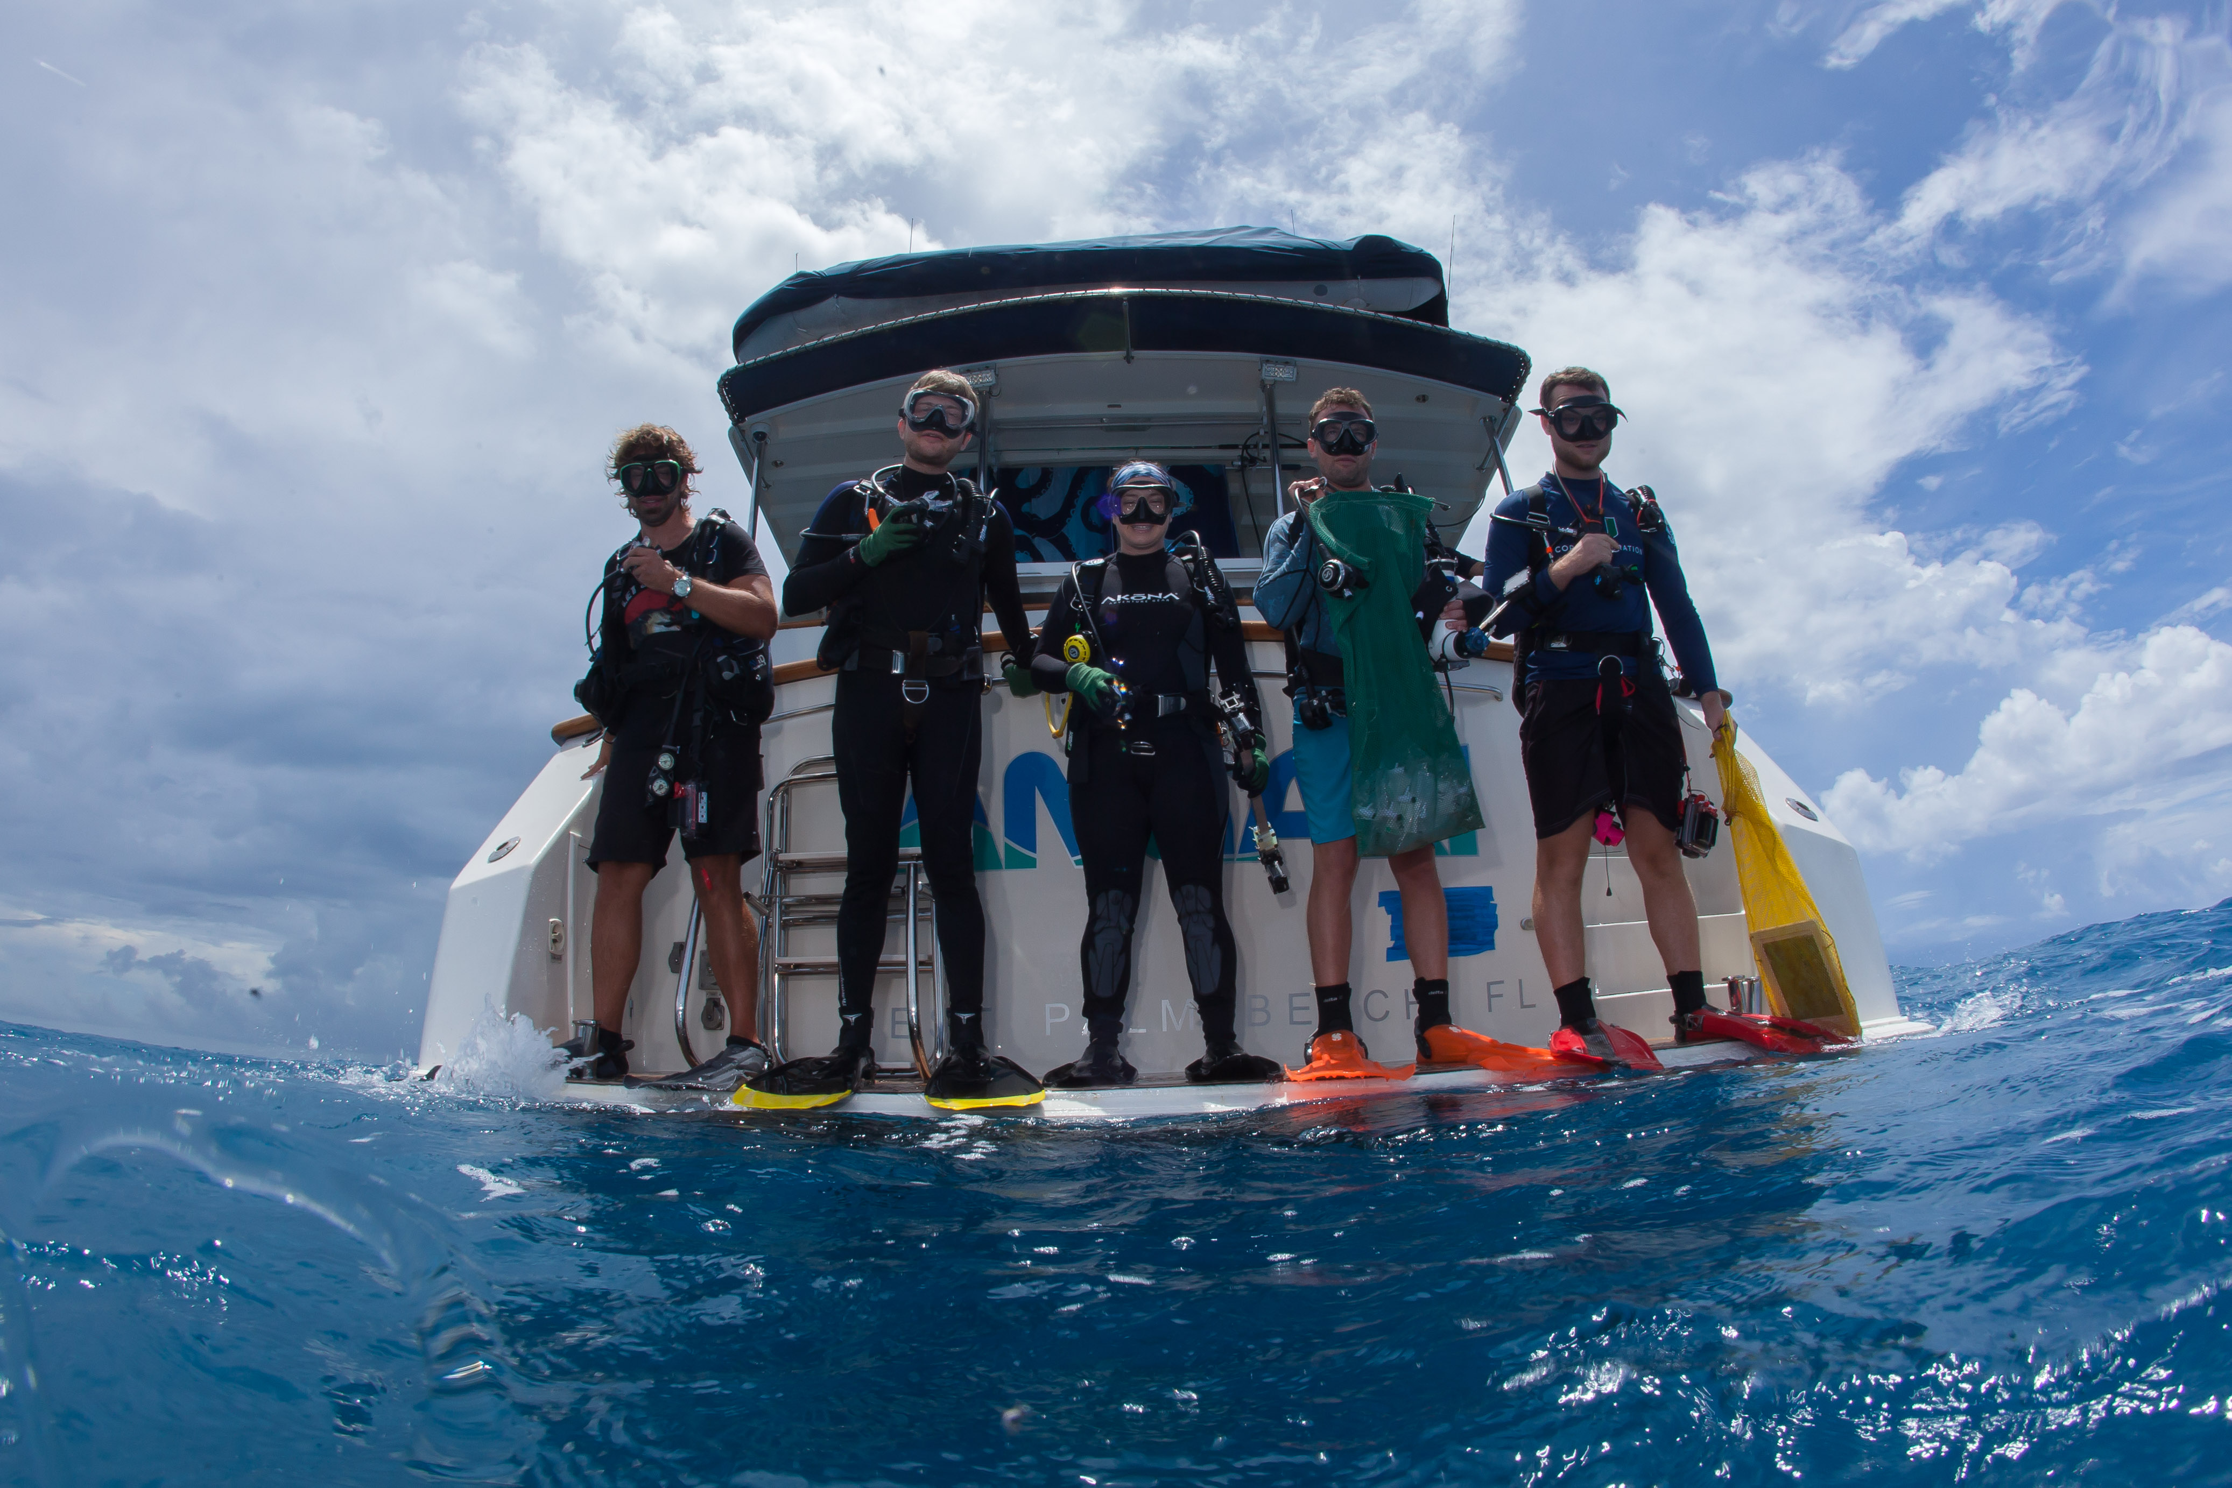

St. Croix, USVI 2022 Field team

**AOMLs NCRMP Atlantic and Caribbean Climate Team**: I. Enochs, N. Besemer, G. Kolodziej, M. Chakraborty, A.Boyd, M. Jankulak, A. Palacio-Castro, A. Webb, B. Chomitz